**Project Proposal:**

Reducing Ocean Noise Pollution in BC Waters for

Orca Populations

In response to Ocean Networks Canada request for proposals: *RFP# ONC 202301: Client-Specific Dashboard Design for Marine Science Data* [1].

By Pedro Augusto Gonçalves Gomes Amaral & Parker DeBruyne

For Dr. Kate Skipsey, Projects Coordinator

February 12th, 2023

Table of Contents

1 ONC’s Goal 3

1.1 Orcas, Echolocation, and Noise Pollution 3

1.2 Goals and Constraints 4

2 Proposed Solution 4

2.1 Solution Overview 4

2.2 Website Design 4

2.3 Website Functions 5

2.4 Our Design Process 5

3 Research Plan and Project Timeline 6

4 Team Credentials 6

4.1 Parker DeBruyne 6

4.1 Pedro Amaral 6

5 Request for Permission 7

6 References 8

**Table of Figures**

**Figure 1: Orca Population vs. Time, adapted from [2] 3**

**Figure 2: Orca Populations in the Straight of Georgia, adapted from [3] 3**

**Figure 3: Ferry Ship Paths in the Straight of Georgia, AIS ship-tracking, adapted from [4] 3**

**Figure 4: Webpage Prototype. 4**

**Figure 5. Visual Representation of The Live Map. 5**

**Figure 6: Planned Work Schedule. 6**

# 1 ONC’s Goal

University of Victoria (UVic)’s Ocean Networks Canada (ONC) manages a cabled network of observation equipment along Canadian coastlines and the deep sea. Their efforts collect and distribute ocean and geological data to researchers and the public.

## 1.1 Orcas, Echolocation, and Noise Pollution

Orca populations dangerously amount to the lowest population rates seen in over 20 years, as seen in **Figure 1** [2]. When they hunt in British Columbia [3], they meet with noise pollution from ferries and freight ships [4]. This distorts their echolocation and undermines their ability to find food, socialize, and coordinate as a pod [5]. For our task, we focused on The Strait of Georgia, off the port of Vancouver, which is a water highway for commercial ships and a local hotspot for orca activity, as seen in **Figures 2 & 3**.

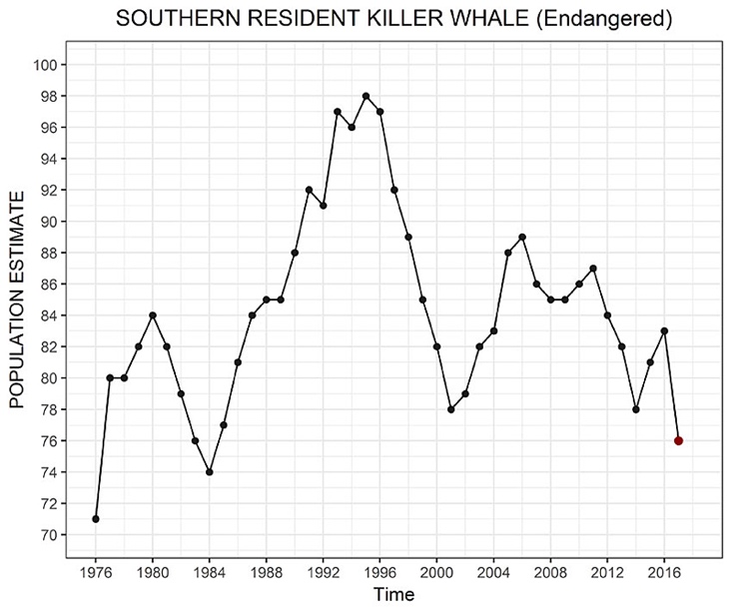

Figure 1: Orca Population vs. Time, adapted from [2].

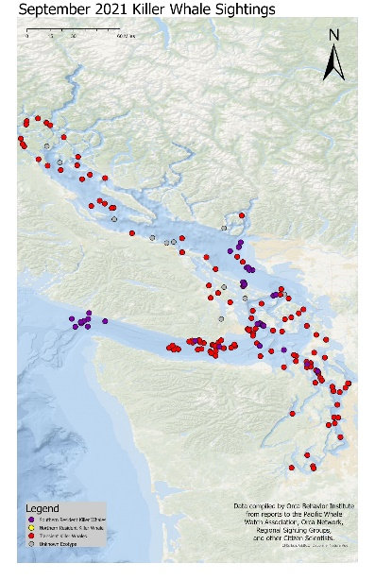

Figure 2: 2021 Orca Sightings in the Strait of Georgia, adapted from [3].

Figure 3: Ferry Ship Paths in the Strait of Georgia, AIS ship-tracking, adapted from [4].

## 1.2 Goals and Constraints

From the RFP, we discerned that a successful solution needs to reduce noise pollution in the Strait of Georgia and constrain itself to the technology available on ships. The goal is to maximize human productivity while minimizing damage to marine life, all while educating the public and informing policy makers to change legislation. Our objective consists of fulfilling ONC’s initial request and the communities’ desires for this project.

# 2 Proposed Solution

We brainstormed several ideas after reading the RFP and tested their feasibility by talking with an ONC scientist, Jasper Kanes [5, 6]. We confirmed that the largest source of marine noise pollution in the Strait of Georgia was commercial ships, and we made Ship Captains our primary userbase.

## 2.1 Solution Overview

Our dashboard design combines an existing technology, live AIS Ship Tracking (similar to **Figure 3**) [7], and a predictor of killer whale hotspots using ONC data and widget APIs. These widgets mix to create a live map for captains. This map calculates the ship’s proximity to hotspots and recommends a safe speed to produce less sound. With this approach, the dashboard creates a balance between facilitating a healthy marine environment while maintaining human productivity.

## 2.2 Website Design

The landing page looks something like **Figure 4**. It contains simple navigation and a clean layout which focuses the user’s attention onto the search bar. When a visitor enters a ship’s name, the section changes to display a live map with the ship’s icon displayed in the center, as seen in **Figure 5**.

Figure 4: Webpage prototype.

Figure 5. Visual Representation of The Live Map.

## 2.3 Website Functions

Zones of orca popularity are shaded in red, called “Orca Areas”, and identified using ONC data. A visual projection of a ship’s sound field changes in size based on speed. At the top, a recommendation for speed changes based on proximity to Orca Areas and varies based on the ship’s weight class. The search icon flips the section back to the original landing page.

Below the first section, scrolling reveals text and visual explanations about echolocation and noise pollution, complete with live data charts from ONC. The charts demonstrate orca population trends and hydrophone readings over decades.

Third, the site contains a form to contact your local Member of Parliament through email. A prewritten message explaining the effects of noise pollution on marine life, and recommended decibel levels, may be sent with the click of a button. The user might choose to edit this message or send it immediately. Finally, links to related charities lie at the bottom of the page.

## 2.4 Our Design Process

Our design approach is called Enterprise Design Thinking; it is the main development strategy employed by IBM and other tech giants [8]. It values the user’s feedback and opinions above our own and forces us to challenge assumptions. It allows us to maximize the accuracy of solving a problem while minimizing the risk and investment involved. It all starts with conducting more research, interviewing users, and prototyping before beginning development.

# 3 Research Plan and Project Timeline

We need to investigate three main concepts: (1) the feasibility of using ONC widgets and AIS tracking together in a website, (2) the effectiveness of speed reduction on marine noise, and (3) the impact of speed reduction on a ship’s productivity. We aim to prove or disprove the benefits that users and marine mammals would garner from our designs. The following graph details our plan to investigate these topics and includes our work up until now:

Figure 6: Planned Work Schedule.

We plan to divide into two sub-teams: research and mock-up design. With this approach, our final proposal to the client will include both significant data and a representation of what real implementation looks like.

# 4 Team Credentials

As a small team, we can move research along quickly and outpace the competition. With our combined backgrounds in software development, we feel confident on researching an efficient and effective webpage at minimal risk to our client.

## Parker DeBruyne

Founder of INSO Web Design, a student-based web development company, Parker gained design experience during an internship with The University of Victoria’s INSPIRE Program: a tech incubator that teaches the IBM’s start-up process to students in STEM fields.

## Pedro Amaral

An ambitious Computer Science at UVic, Pedro excels at programming and has design experience in videogames. His background brings insight into the user experience and guides the interview and research process.

# 5 Request for Permission

Marine noise pollution interrupts an orca’s echolocation and prevents them from finding food [3]. Small reductions in ship speed can cause large decreases in noise pollution, but captains need to know where to slow down and by how much. Our webpage design will provide the following: (1) a live map for captains with speed recommendations, (2) visuals and charts to educate the public on echolocation and noise pollution, (3) a method of contacting Members of Parliament to push for decibel regulation, and (4) donation links to related charities.

We have already designed a simple visual prototype for this website and have a plan to research our assumptions and test the dashboard with our userbase. We are confident that ONC data can be combined with existing technology to create an educational experience for the public and make a positive impact on BC marine life. To continue with the project, we request permission to further our research based on the already described goals and parameters.

We look forward to your response,

* Parker & Pedro

# 6 References

[1] Ocean Networks Canada. “*Request for Proposals: RFP# ONC 202301.”* Bright.uvic.ca, Spring 2023 ENGR 240 A03, 3. DOCUMENT DESIGN and CLIENT MEMO, Client Memo – Assignment Description, <https://bright.uvic.ca//content/enforced/227371-202301ENGR240A03(21365)CO/ENGR240%20RFP%20ONC%202023.pdf?isCourseFile=true&_&d2lSessionVal=bzgHt6IQcR3vSNddofI2LnfIb&ou=227371>, (accessed Feb. 13th, 2023).

[2] C. Kilduff, R. Krehbiel, W. Neugebauer, C. Weiler. “*Critically Endangered Puget Sound Orcas Lose Another Member.*” BiologicalDiversity.org, <https://www.biologicaldiversity.org/news/press_releases/2017/orca-09-25-2017.php>, (accessed Feb. 13th, 2023).

[3] Orca Behavior Institute. “*September 2021 Killer Whale Sightings.”* FaceBook.com, <https://www.facebook.com/orcabehavior/photos/here-is-the-september-2021-map-for-orca-sightings-in-the-salish-seafinally-there/2727923284178314/?paipv=0&eav=AfbQ9qET9-VigD1msJUi88Dpbt_Hy1DHQG0LsAl7I5JC2CwtKJrWH_XLdhSCg5HQ3CE&_rdr> (accessed Feb. 13th, 2023).

[4] Marine Traffic. “*Live Map*”, MarineTraffic.com, <https://www.marinetraffic.com/en/ais/home/centerx:-123.6/centery:49.2/zoom:10>, (accessed Feb. 13th, 2023).

[5] P. DeBruyne. “*Parker, Pedro, and ONC Meeting.*” Zoom.us, Recordings, <https://zoom.us/recording>, (accessed Feb. 13th, 2023).

[6] J. Kanes. “*ONC Staff Profile, Jasper Kanes.”* OceanNetworks.ca, <https://www-static01.oceannetworks.ca/about-us/organization/staff/Kristen-Kanes-2.html>, (accessed Feb. 13th, 2023).

[7] International Maritime Organization. “*AIS Transponders.*” IMO.org, <https://www.imo.org/en/OurWork/Safety/Pages/AIS.aspx>, (accessed Feb. 13th, 2023).

[8] Voltage Control, “*What is Enterprise Design Thinking?*” VoltageControl.com, <https://voltagecontrol.com/blog/what-is-enterprise-design-thinking/>, (accessed Feb. 13th, 2023).